C.V. RAMAN GLOBAL UNIVERSITY

BHUBANESWAR, ODISHA-752054

DEPARTMENT OF COMPUTER SCIENCE & ENGINEERING



DMDW CASE STUDIES AND PROJECT REPORT

Name: - Satya Narayan Gope

Reg no.: - 20010433

Branch: - CSE (DATA SCIENCE)

Under the Supervision of

ANJANA MISHRA

DEPARTMENT OF COMPUTER SCIENCE AND ENGINEERING

C.V. RAMAN GLOBAL UNIVERSITY

DEPARTMENT OF COMPUTER SCIENCE & ENGINEERING



DMDW CASE STUDIES AND PROJECT REPORT

**TOPIC:- VOICE ASSISTANT (A.I.)**

**(Text to speech)**

**GROUP MEMBERS**

|  |  |
| --- | --- |
| **NAME** | **REGISTRATION NUMBER** |
| SATYA NARAYAN GOPE | 20010433 |
| PRAVIR KUMAR PRADHAN | 20010451 |
| SUPREET PARIDA | 20010459 |
| SHISHIR RAJ | 20010432 |
| BHIBU PRASAD SAHOO | 20010465 |

1. **INTRODUCTION**

**1.1:PURPOSE**

Purpose of virtual assistant is to being capable of voice interaction, music playback, making to-do lists, setting alarms, streaming podcasts, playing audiobooks, and providing weather, traffic, sports, and other real-time information, such as news. Virtual assistants enable users to speak natural language voice commands in order to operate the device and its apps. There is an increased overall awareness and a higher level of comfort demonstrated specifically by millennial consumers. In this ever-evolving digital world where speed, efficiency, and convenience are constantly being optimized, it’s clear that we are moving towards less screen interaction.

The project aims to develop a non-public assistant for Computers (computer Personal Assistant). It provides an easy interface for finishing a selection of tasks by using bound well-defined commands. Users will move with the

assistant through voice commands. As a non-public assistant, it assists the end-user with regular activities sort as general human spoken communication, looking out queries, reading the most recent news, translating words, live weather, and causation mail through voice.

The software package uses a device’s electro-acoustic transducer to receive voice requests whereas the output takes place at the system’s speaker.

**1.2:Field of Research**

The below mentioned pie chart shows the analysis of virtual assistants in context to education as well as purpose of this work with a total of papers from 13 countries. The highest contribution was made by country England with most number of papers (3), followed by Russia and Switzerland (2 papers each). The remaining countries, namely Singapore, Pakistan, Canada, India, France, Bulgaria, Saudi Arabia and Germany are also mentioned with 1 paper each.

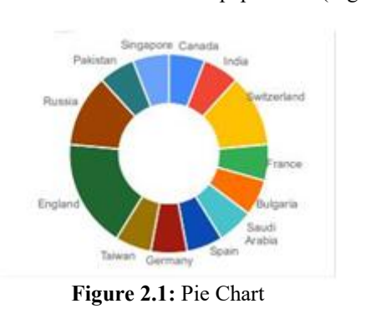

The below displayed bar graph shows that growth is continuous in research papers since 2000, except the year

2010 .

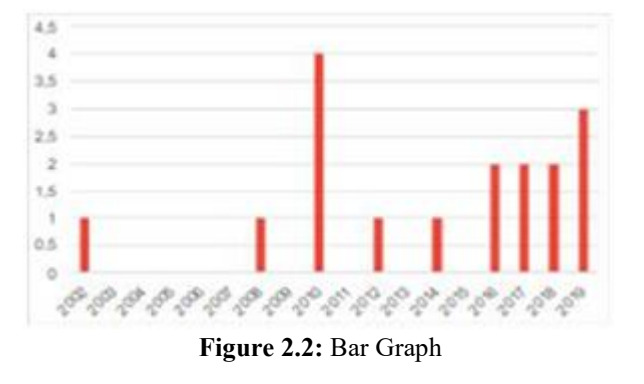

Artificial Intelligence programs have currently become capable of difficult humans by providing professional Systems, Natural Language Processing (NLP), and Speech Recognition. Computer science brings a bright future for various technical inventions in various fields. This case study shows the final thought of computer science, and therefore the use of speech recognition, and gifts the impact of computer science within the present and future world.

**1.4:Findings and Issues**

Everything that a human being can do is being transformed by machines in this era. One of the key causes is the performance exchange. In today's society, we teach our machines to think like people and complete their missions on their own. As a result, the concept of a digital assistant emerged. A digital assistant that understands voice commands and does

relevant tasks as requested by the user using voice reputation features and language processing algorithms. A digital assistant is capable of filtering

out ambient noise and returning relevant facts based on particular commands supplied by the person. Virtual Assistants are entirely software-based, but they've recently been integrated into a variety of devices, and some, such as Alexa, are created specifically for standalone devices Because of the rapid change in era, it is now more important than ever to educate our machines using machine learning, deep learning, and neural networks.

The main issue of this system is that it has to be always connected with the network as the pyttx3 works only in online mode. The limitation of the project that includes that any particular word like google and siri has that the “The Hotword” command that is nothing but the wake up command for any A.I system it has no wake up command it can’t unlock your device it has to be in running position.

**1.4:Theory**

Artificial Intelligence when used with machines, it shows us the capability of

thinking like humans. In this, a computer system is designed in such a way that

typically requires interaction from human. As we know Python is an emerging

language so it becomes easy to write a script for Voice Assistant in Python. The

instructions for the assistant can be handled as per the requirement of user.

Speech recognition is the Alexa, Siri, etc. In Python there is an API called

**Speech Recognition** which allows us to convert speech into text. It was an

interesting task to make our own assistant. It became easier to send emails

without typing any word, Searching on Google without opening the browser,

and performing many other daily tasks like playing music, opening your

favorite website with the help of a single voice command. In the current scenario,

advancement in technologies are such that they can perform any task with same

effectiveness or can say more effectively than us. By making this project, We

realized that the concept of AI in every field is decreasing human effort and

saving time.

The functionalities include , It can send emails, It can read PDF, It can send

text on WhatsApp, It can open command prompt, your favorite website, notepad

etc., It can play music, It can do Wikipedia searches for you, It can open

websites like Google, YouTube, etc., in a web browser, It can give weather

forecast. It can have some basic conversation.

Tools and technologies used are **VS CODE IDE** for making this project.

Along with this we used following modules and libraries in our project. pyttsx3, SpeechRecognition, Datetime, Wikipedia, Smtplib, pywhatkit, pyjokes, pyPDF2, pyautogui, pyQt etc. we have created a live GUI for interacting with the AI (FRIDAY) as it gives a design and interesting look while having the conversation.

1. **Problems/ Challenges**

1.**Mnually:-**Usually, user needs to manually manage multiple sets of applications to complete one task. For example, a user trying to make a travel plan needs to check for airport codes for nearby airports and then check travel sites for tickets between combinations of airports to reach the destination. There is need of a system that can manage tasks effortlessly. We already have multiple virtual assistants. But we hardly use it.

2.**Time saver:-** For working in any PC or desktop it takes quite time for opening or searching things in online as well as in offline mode. Sometimes the user is unable to reach the required or desired location. In that case voice modulation and voice command makes things easier to be done. They help the user to save time.

3**.Recognizing accent:-** There are number of people who have issues in voice recognition. These systems can understand English phrases but they fail to recognize in our accent. Our way of pronunciation is way distinct from theirs. Also, they are easy to use on mobile devices than desktop systems. There is need of a virtual assistant that can understand English in Indian accent and work on desktop system.

4.**Efficiency:-** When a virtual assistant is not able to answer questions accurately, it’s because it lacks the proper context or doesn’t understand the intent of the question. Its ability to answer questions relevantly only happens with rigorous optimization, involving both humans and machine learning. Continuously ensuring solid quality control strategies will also help manage the risk of the virtual assistant learning undesired bad behaviours. They require large amount of information to be fed in order for it to work efficiently. Virtual assistant should be able to model complex task dependencies and use these models to recommend optimized plans for the user. It needs to be tested for finding optimum paths when a task has multiple sub-tasks and each sub-task can have its own sub-tasks. In such a case there can be multiple solutions to paths, and the it should be able to consider user preferences, other active tasks, priorities in order to recommend a particular plan.

1. **Discussion:-**

**3.1:Summeriesation of problems:-**

So the main problems are: lack of efficiency and lots of time taken during the execution of any task. The multitasking also affects the user and it also turns out a major problem while working with desktop.

**3.1:Alternate Solutions:-**

* **Make shortcuts:**

It is one of the solution which mainly focus to make any shortcut or app to perform any task and function.

For example to shut down a user can make a shortcut by making shortcut in desktop



And type:- shutdown -s -t 0

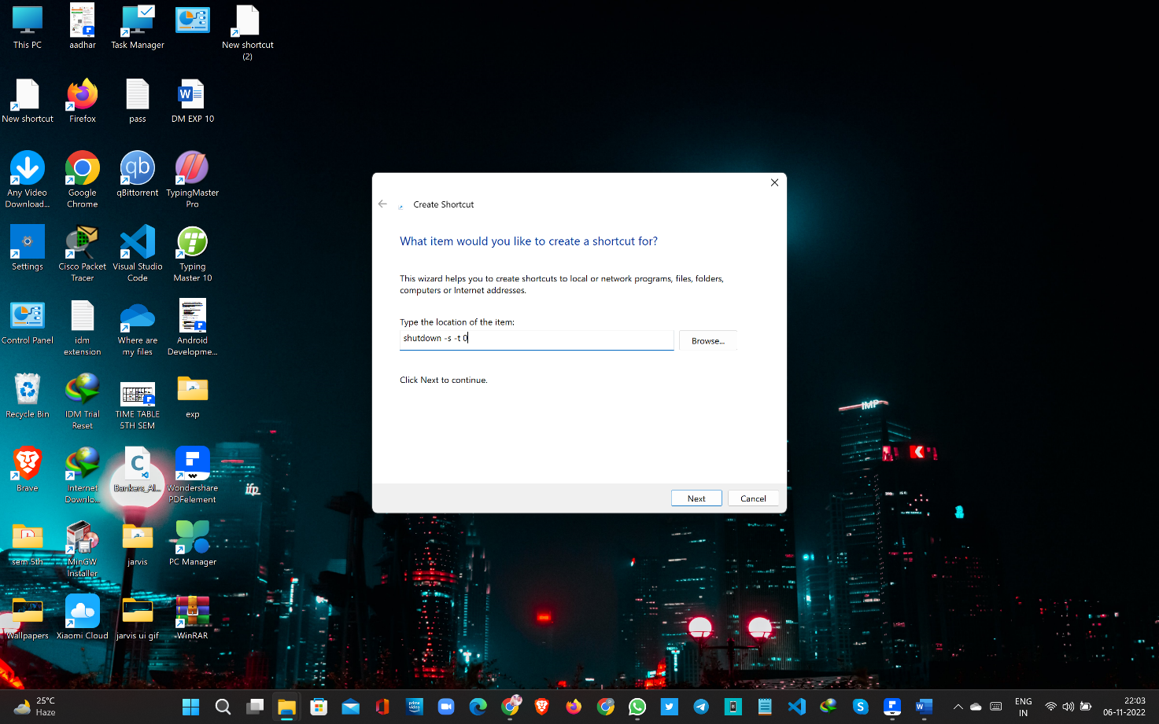

It will make a shortcut for shutdown the system.



**Advantages:-**

The user need not to go to the whole process and execute any task rather than just click the double button and it will execute any task.

**Disadvantages:-**

* Its very complicated process as for each task its really difficult to make shortcut for every task.
* The user need to physically approach the desktop to make it work or execute.
* **Using voice command apps:**

The alternate solution of these problems can be downloading an outside apps that can work with voice command.



**Advantages:-**

* The user need not to perform manually any task and wait for the execution any program and app.
* Installation is quite easy and no need to go through the whole set up process.

**Disadvantages:-**

* The security of the system is affected by using these third party app.
* Giving all the permission means the third party apps can access personal and professional data of users.

**So the best possible solution would be**

* **Make your own Voice Assistant:**

A desktop assistant is a voice assistant that can perform many daily tasks

of desktop like playing music, opening your favorite IDE with the help of a single voice command.

**Advantage:-**

It is different from other traditional voice assistants in terms that it is specific to desktop and user does not need to make account to use this.

With the help of voice assistant user can easily optimize and use the functions of desktop only providing the commands.The user need not to manually operate any function.

1. **Implementation and solution:**

**System Requirement**

The IDE used in this project is VSCODE. All the python files were created in

VSCODE and all the necessary packages were easily installable in this IDE.

For this project following modules and libraries were used i.e. pyttsx3,

SpeechRecognition, Datetime, Wikipedia, Smtplib, pywhatkit, pyjokes,

pyPDF2, pyautogui, pyQt etc. We have created a live GUI for interacting with

the FRIDAY(voice assistant) as it gives a design and interesting look while having the conversation.

* **VS-CODE:-**

It is an IDE i.e. Integrated Development Environment which has many features

like it supports scientific tools(like matplotlib, numpy, scipy etc) web frameworks

(example Django,web2py and Flask) refactoring in Python, integrated python

debugger, code completion, code and project navigation etc.

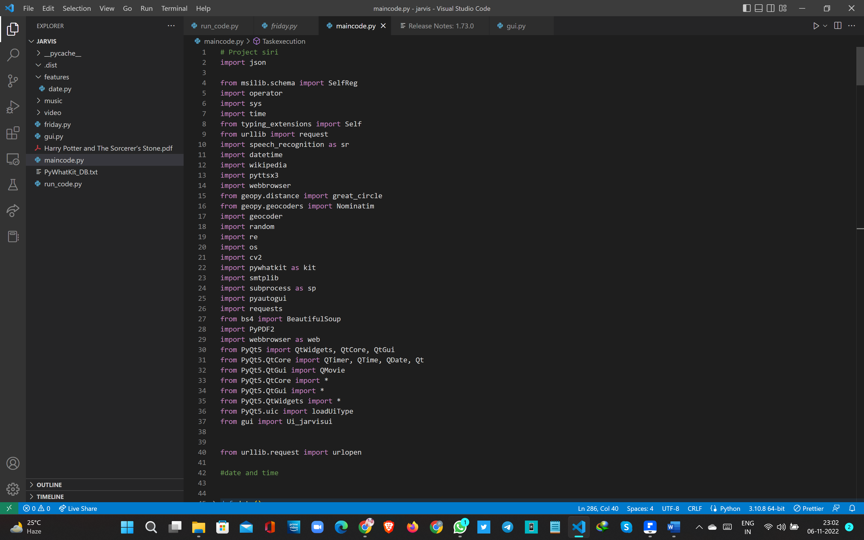

* **PYQT5 FOR LIVE GUI:-**

PyQt5 is the most important python binding. It contains set of GUI

widgets. PyQt5 has some important python modules like QTWidgets,

QtCore, QtGui, and QtDesigner etc.

PyQt5 is the most important python binding. It contains set of GUI

widgets. PyQt5 has some important python modules like QTWidgets,

QtCore, QtGui, and QtDesigner etc.



* **PYTHON LIBRARIES:-**

In JARVIS following python libraries were used:

* **Pyttsx3:** It is a python library which converts text to speech.
* **SpeechRecognition:** It is a python module which converts speech to text.
* **Pywhatkit:** It is python library to send WhatsApp message at a particular time with some additional features.
* **Wikipedia:** It is a python module for searching anything on
* **Wikipedia.Smtplib:** Simple mail transfer protocol that allows us to send mails and to route mails between mail servers..
* **PyPDF2:** It is a python module which can read, split, merge any PDF.
* **Pyjokes:** It is a python libararies which contains lots of interesting jokes in it.
* **Web Browser:** It provides interface for displaying web-based documents to users.
* **Pyautogui:**  It is a python libraries for graphical user interface.
* **OS:** It represents Operating System related functionality.
* **System:** It allows operating on the interpreter as it provides access to the variables and functions that usually interact strongly with the interpreter.

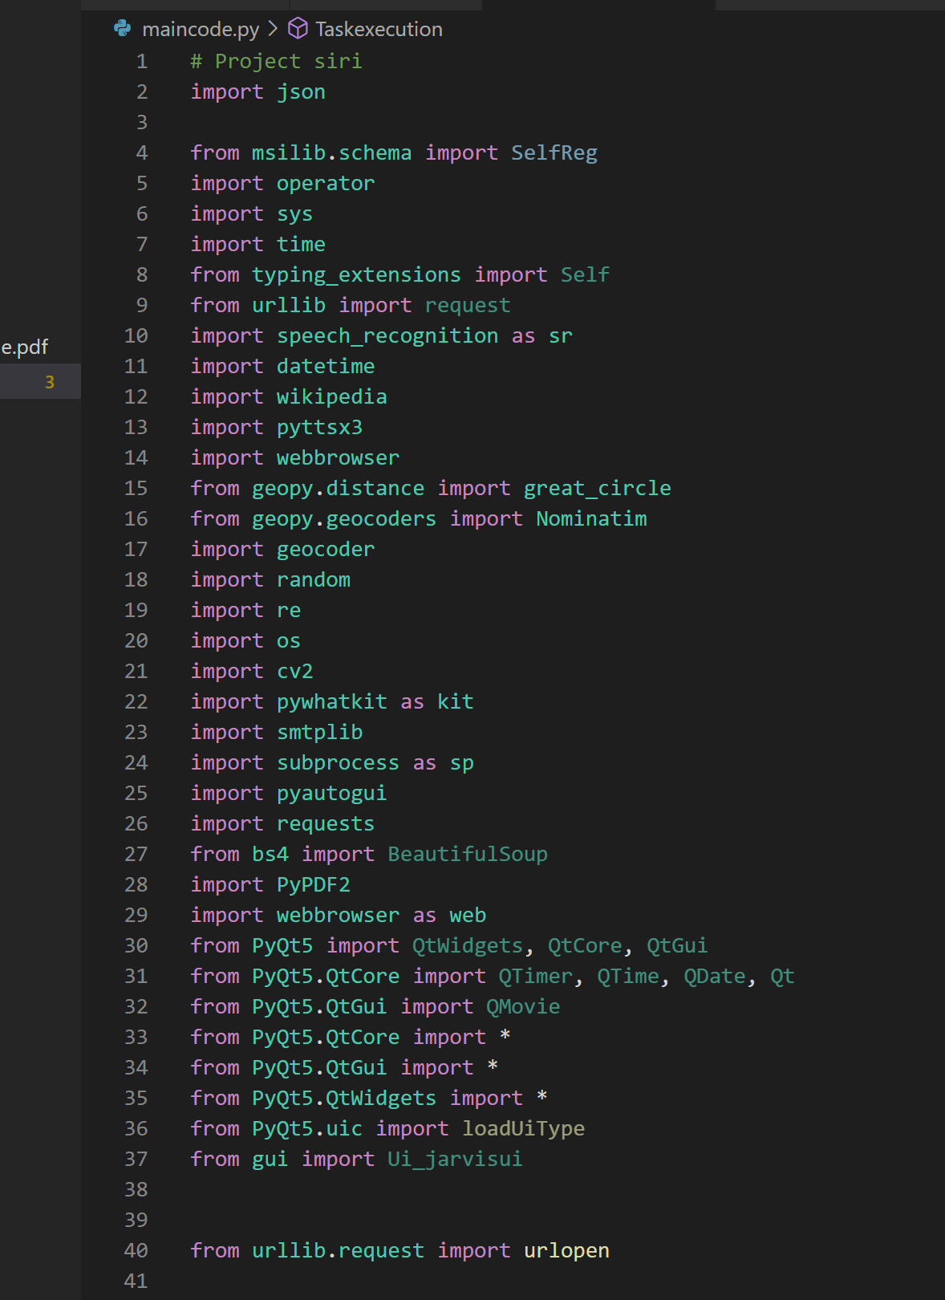

* **Working:-**

It works in three stages:-

1. **User command:-**  It takes the user command and according to it works and execute any task.
2. **Processing:-** According to the command it process the task and execute it.
3. **Restart:-** After completing the task it is again ready to take command.

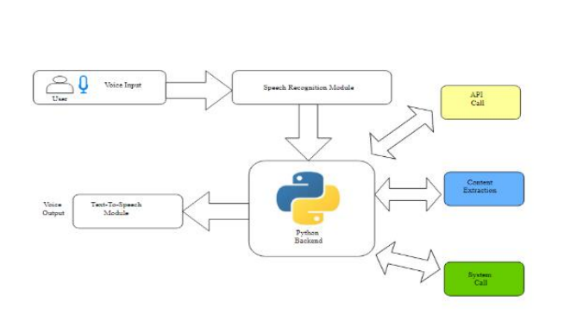

**Methodology:-**

**A.Speech Recognition :**

The system uses Google’s online speech recognition system for converting speech input to text. The speech input Users can obtain texts from the special corpora organized on the computer network server at the information center from the microphone is temporarily stored in the system which is then sent to Google cloud for speech recognition. The equivalent text is then received and fed to the central processor.

**B. Python Backend :**

The python backend parses the voice recognition module's output to determine whether the command or speech output is an API Call, Context Extraction, or System Call. The output is then sent back to the python backend to provide the user with the desired results.

**C. API Calls :**

The acronym for Application Programming Interface (API) is Application Programming Interface. An API is a software interface that allows two apps to communicate with one another.To put it another way, an API is the messenger that sends your request to the provider and then returns the result. In this program we have used **openwheathermap** API to get the information about the wheather condition of any place and **newsapi** to get the news.

**D. Context Extraction :**

Context extraction (CE) is the process of obtaining structured data from machine-readable materials that are unstructured or semi-structured. The majority of

the time, this activity entails using natural language processing to process human language texts (NLP). TEST RESULTS for context extraction can be seen in recent activities in multimedia document processing, such as automatic annotation and content extraction from images/audio/video.

**E. System Calls :**

The mechanism through which a computer software requests a service from the kernel of the operating system on which it is running is known as a system call. Hardware-related services (for example, accessing a hard disc drive), the creation and execution of new processes, and communication with core kernel

services such as process scheduling are all examples of this. A process's interface with the operating system is provided by system calls.

* **FUNCTIONS:-**

**takeCommand():** The function is used to take the command as input through

microphone of user and returns the output as string.

**wishMe():** This function greets the user according to the time like Good Morning,

Good Afternoon and Good Evening.

**taskExecution():** This is the function which contains all the necessary task execution definition like sendEmail(), pdf_reader(), news() and many conditions in if condition like “open google”, “open notepad”, “search on Wikipedia” ,”play music” and “open command prompt” etc.

**date() and time():** This is the function which is used to show the current date and time.

**tell me about():**- To access any information from Wikipedia.

**Openapp():**- This function is used to open any app.

**GUI (GRAPHICAL USER INTERFACE):-**

**SOURCE CODE:-**

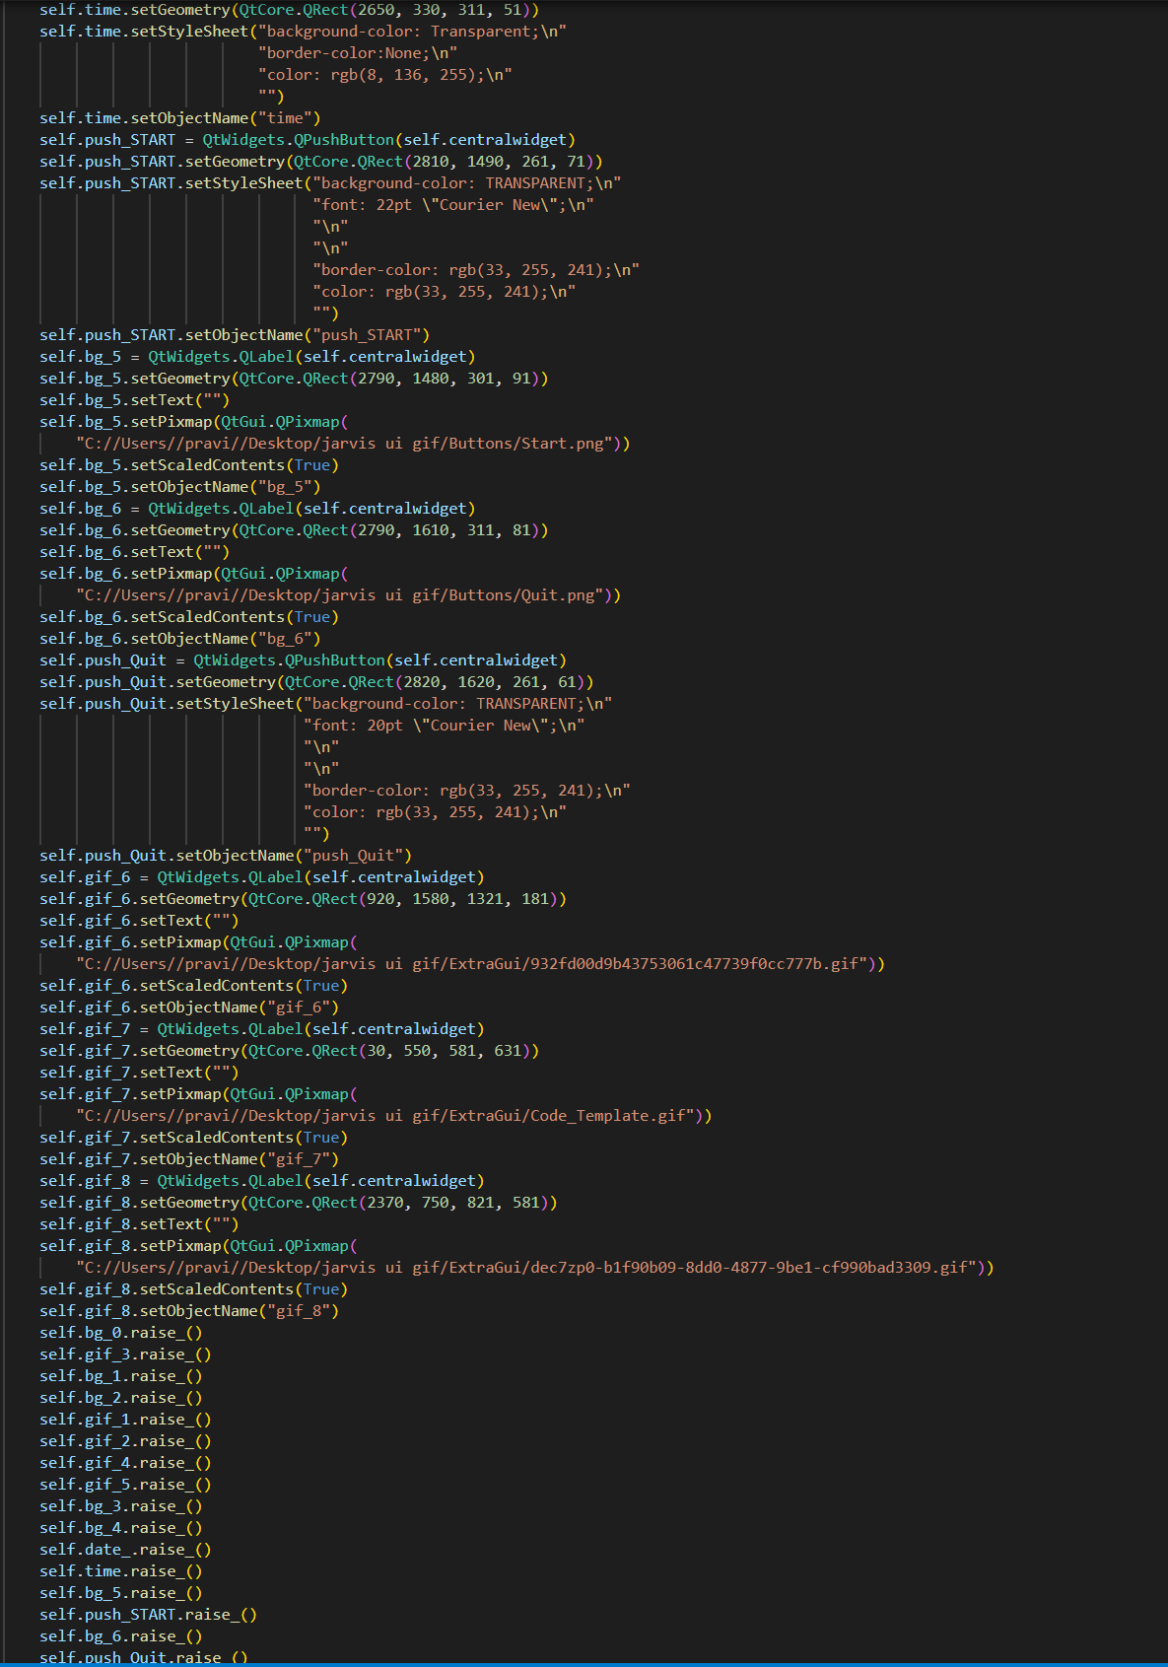

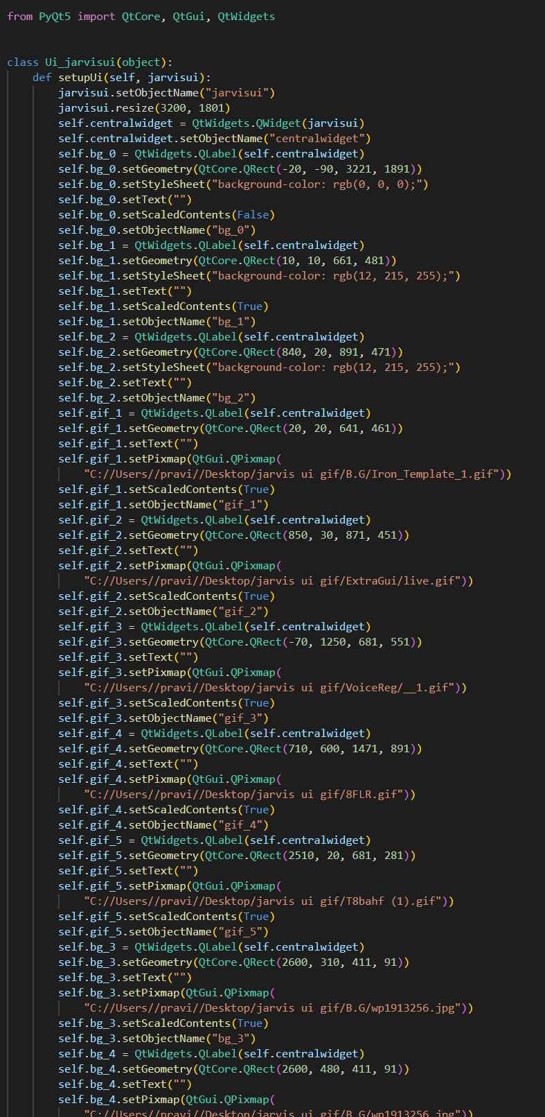

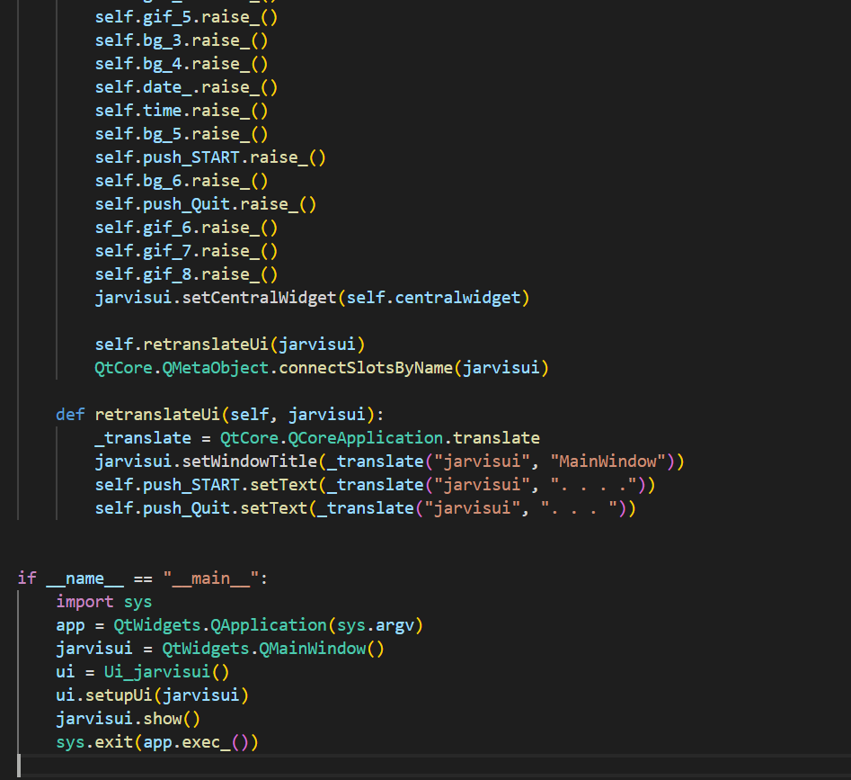

**OUTPUT:-**

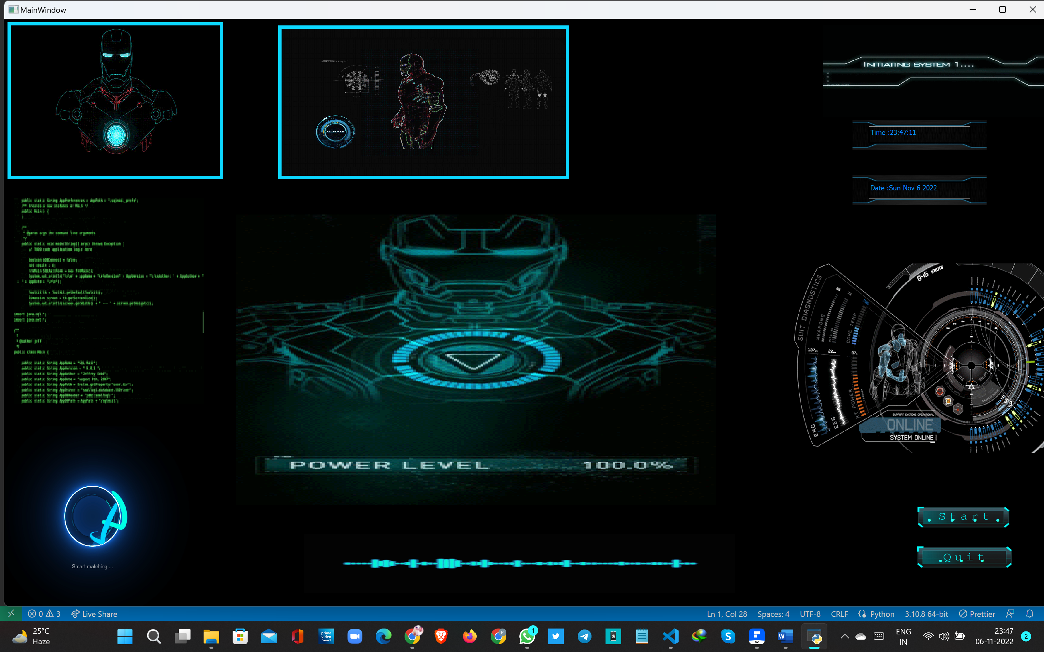

**Task performed:-**

1. **Opening apps:-**

command:- “open command prompt”

output:- opening command prompt

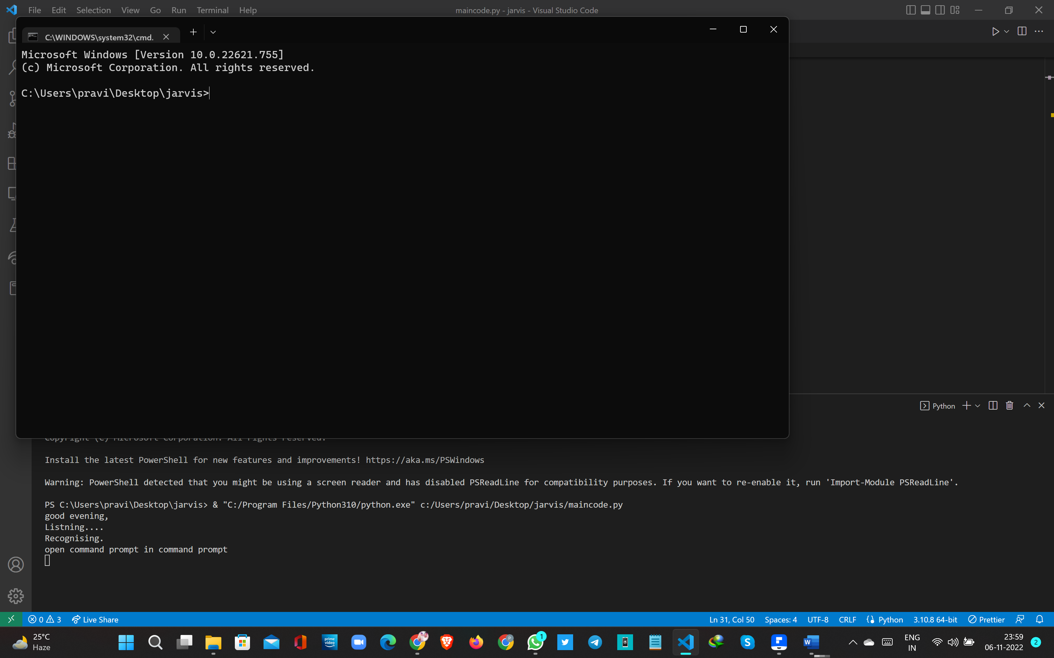

1. **Opening websites:-**

command:- “open youtube”

output:- opening youtube

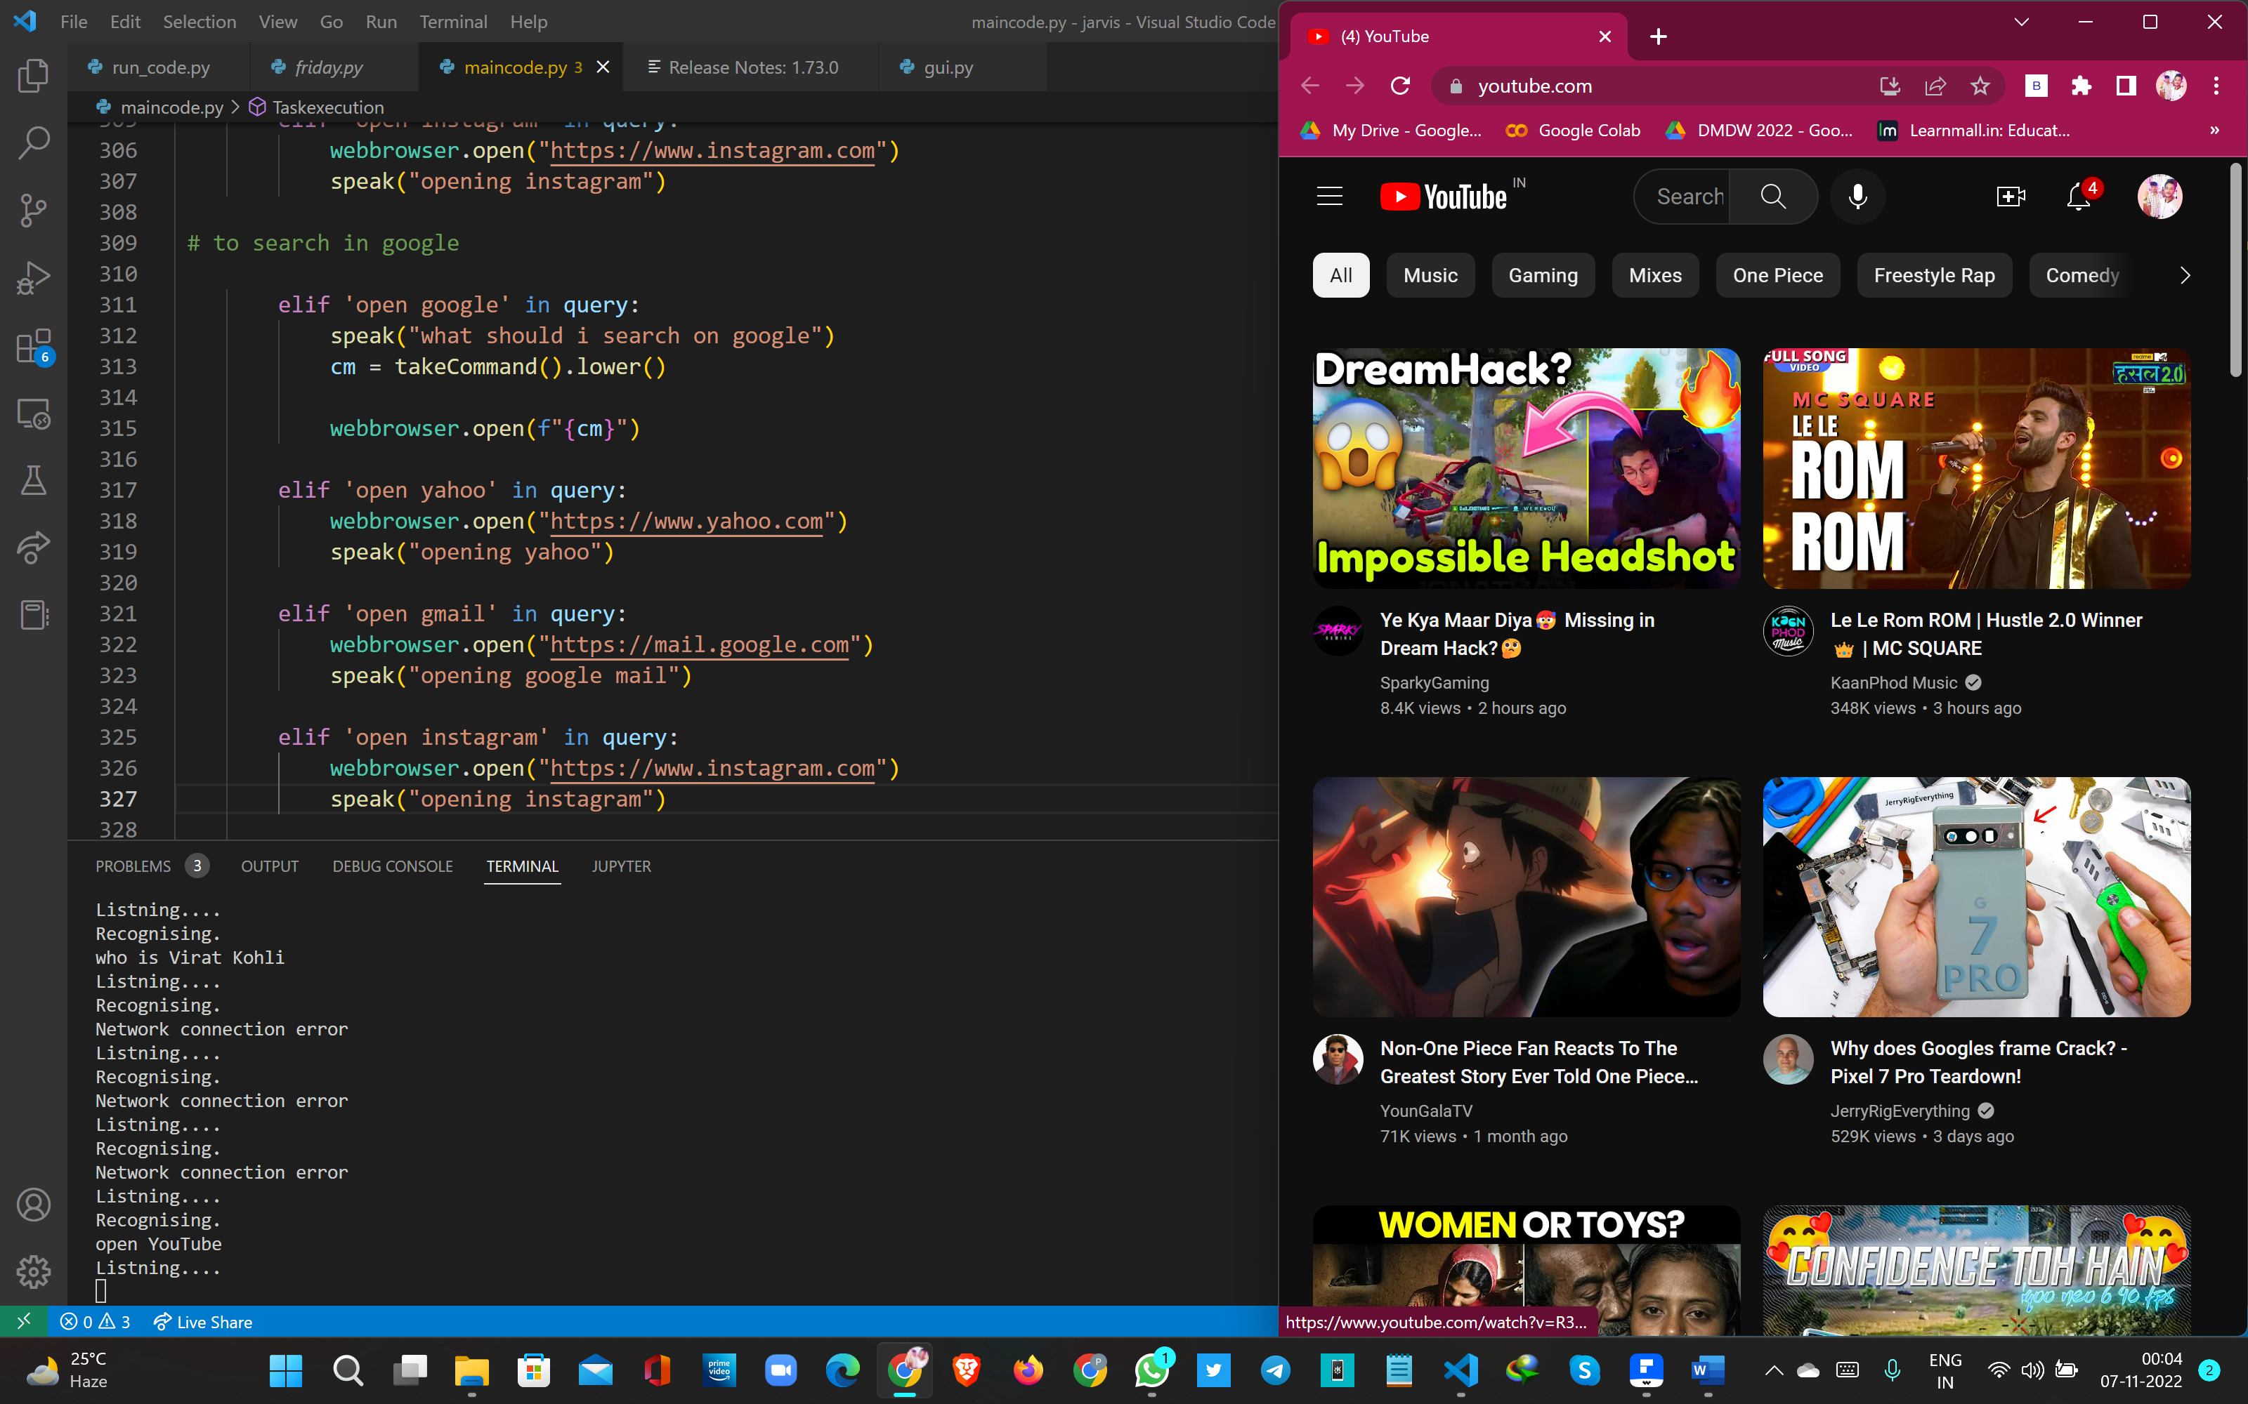

1. **Search in google :-**

command:- “open google ”

output:- opening google

what should I search

“who is virat kohli”

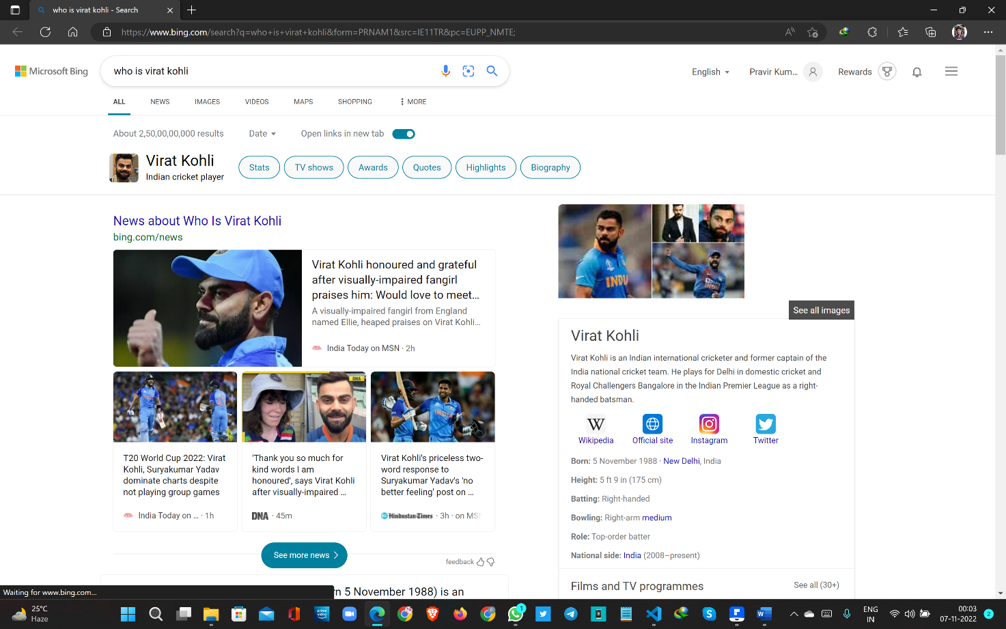

1. **About weather conditions:-**

command:- “what is the weather in odisha ”

output:-

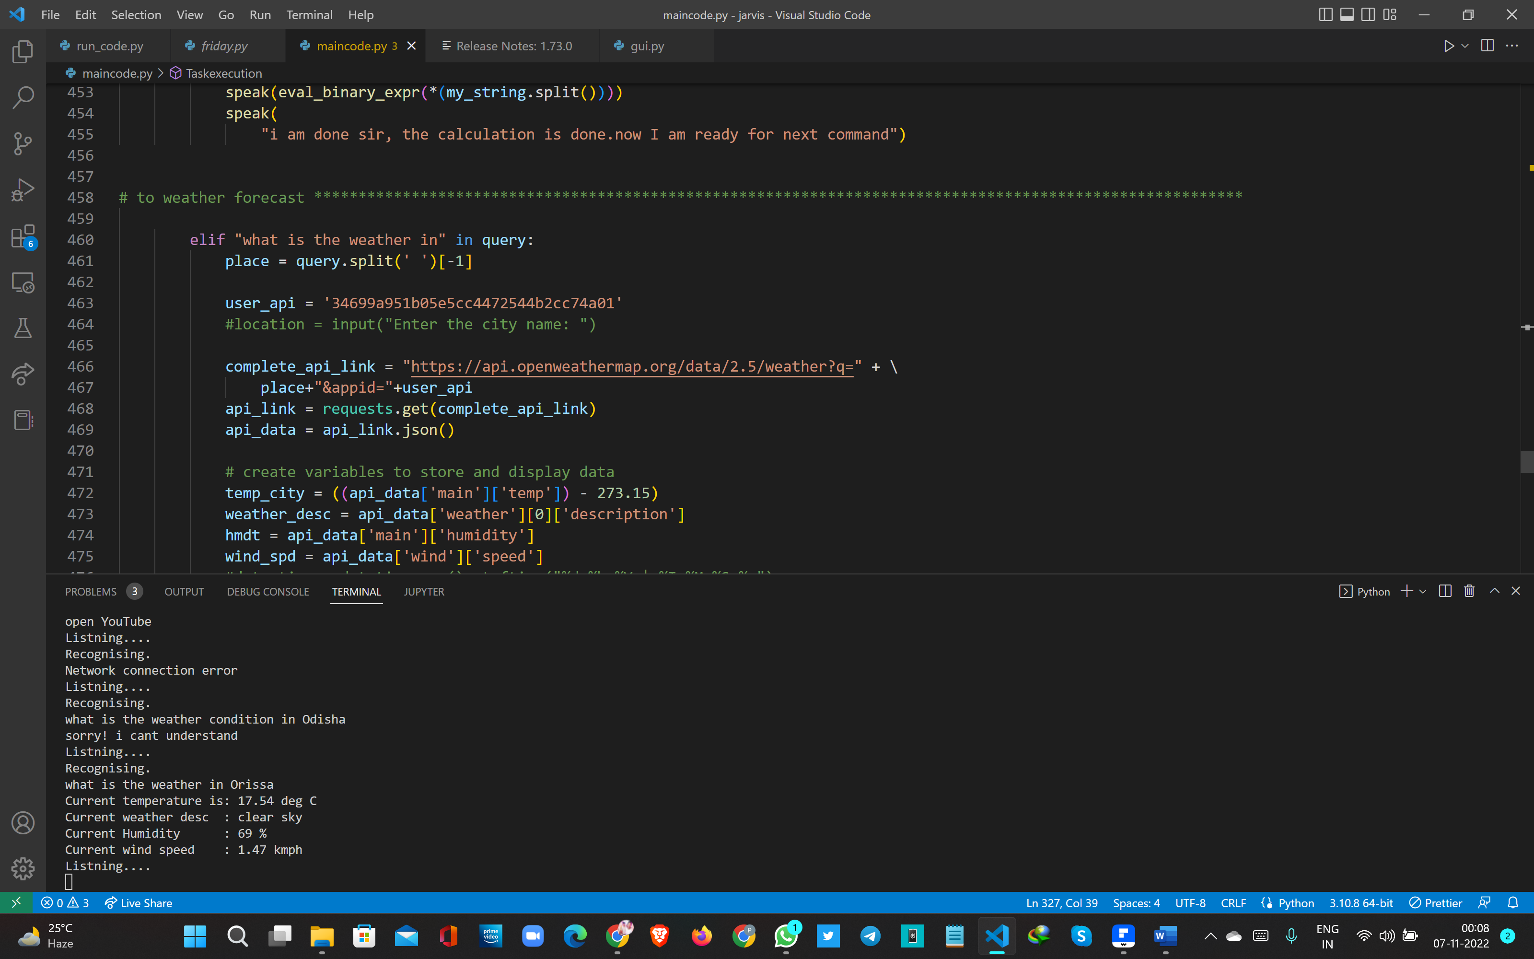

1. **Take Screenshot**

command:- “take a screenshot ”

output:-

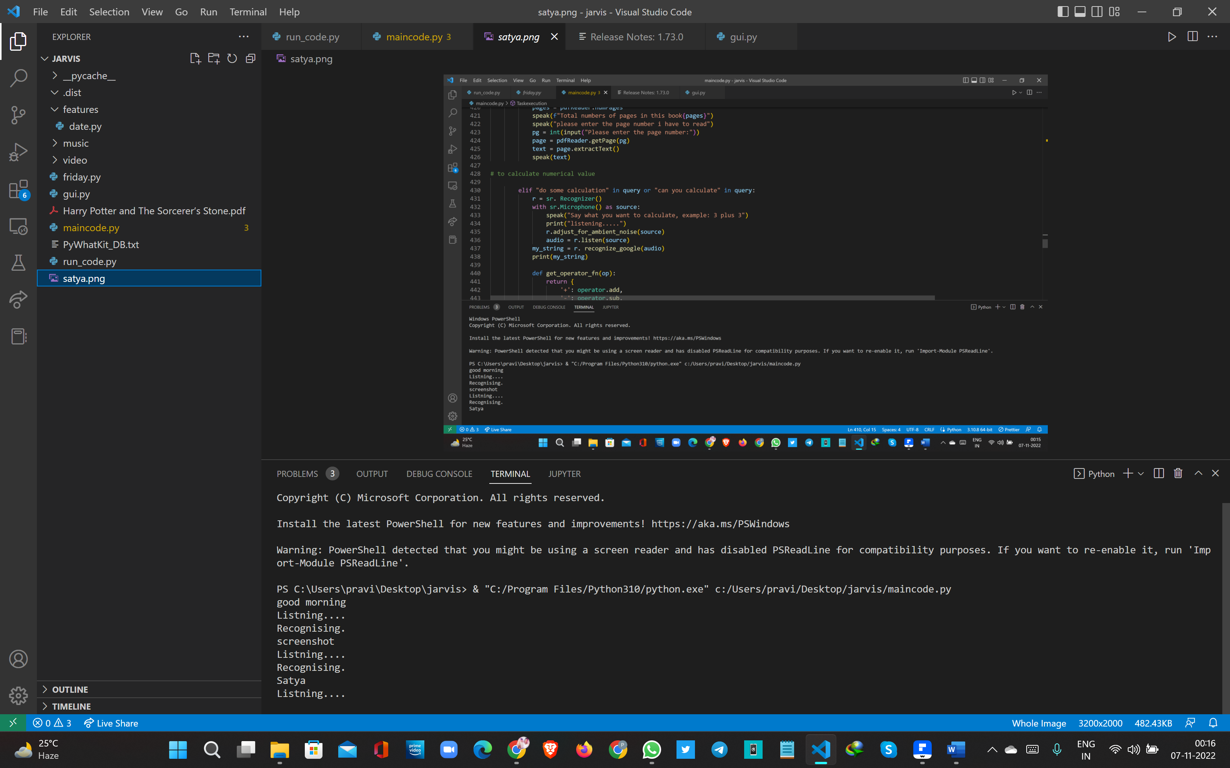

1. **Play music or video**

command:- “open music or play music”

output:- ok I am playing music or video



**These are some important tasks mention above the other tasks that can be performed by this programs are:-**

* **Send mail**
* **Tell about current date and time**
* **Opening websites**
* **Closing websites**
* **Play music on YouTube**
* **Give your current location**
* **Find place locations**
* **Read a pdf**
* **Do some calculation**
* **Shut down restart and sleep the system**

1. **CONCLUSION:**

In this study we have discussed about voice assistance for windows using python. voice assistance makes life easier to humans. As like Google assistance and Cortana we make voice assistance to be available to all the windows version, We use Artificial intelligence technology for this project, voice assistance be able to do all the tasks like other assistance including some special functions like restarting the devices, locking the device, sleeping the device for some particular time and shutdown the device with our voice input. We can expect this voice assistance to be permanent.

An AI Voice Assistant System uses speech recoginition and other AI techniques along with Natural Language Processing for a smart responsive system to the given circumstances or conditions. It can reduce the workload of basic human activities or the daily activities and can replace some human working posts like personal secretaries employed for scheduling a person’s per day time table. Critically, the system is designed to interrelate with other sub-systems smartly and comprehensively.

The system will have the following phases: Input phase in which data or query given in form of text or speech, Interpretation of voice to text, Processing and storing of data, producing output in the form of voice from the refined text to Jarvis console. The information produced at each step can then be used to retrieve patterns and analyze them for later use. This could be the main basis for artificial intelligence machines to learn and recognize patterns for people. So, based on a literature study and analysis of persisting systems, the conclusion is derived that our provided system will not only facilitate interaction with systems and modules but also keep users more organized.

1. **REFERENCES:**

**Youtube links:-**

* **AI Complete playlist:- https://youtube.com/playlist?list=PLq_SHLFD-pSD_LeiV2dyAHgED7PDF48Jq**
* **Gui (complete playlist):-** [**https://youtube.com/playlist?list=PLS1QulWo1RIZiBcTr5urECberTITj7gjA**](https://youtube.com/playlist?list=PLS1QulWo1RIZiBcTr5urECberTITj7gjA)

**FOR API:-** <https://openweathermap.org/api>

**Github:**- https://github.com/Gladiator07/JARVIS